Customer Retention Project

Code Cleanup & View Creation
Preparation day is all about making sure the dataset is cleaned with python to ensure it is ready for analysis and querying. The data cleaning steps in preparation folder include –
- Structural Triage – checking shape & columns before cleaning starts
- Duplication removal – removing duplicates from the dataset to ensure efficient analysis
- Data type alignment – checking if datatype are the same for each column
- Missing data removal – removed null city values in the dataset using group by
Code cleanup was done as the first thing before day 1 analysis to ensure there is no erroneous data.

Day 1 – Basic Analysis
Day 1 analysis includes table creation and finding out the basic knowledge that can be gained by some lines of SQL. The cleaned csv is exported from python notebook, and a new table is created in the Xampp phpMyAdmin’s MySQL server with SQL.
The basic analysis is carried out after the table is created and the main objective for day 1 is to find the most popular product, best selling year, ship mode used by specific customer.
These insights can be foundation for the further analysis in finding which customers are churning/leaving the retail shop.

Findings
Most popular product – Staple envelope (47 order count)
Best selling year – 2018 with $722051.96 in sales
Ship mode usage by customer type –
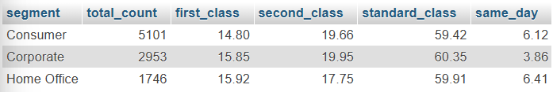
Figure 1 Shipment usage by customer type

Day 2 – Sales Details
For day 2 the analysis focusing on sales details is made to find one-time purchased orders, standard orders, and regular orders as well as the all-time sales. This is the foundation for finding who are regulars and who are one-time purchasing customers in retail sales.

Findings
One-time orders – 28 ($5181.76 in sales)
Standard orders – 8707 ($2020562.20 in sales)
Regular orders – 1065 ($235793.01 in sales)
Total sales - $2261536.97 in sales
The findings show the number of customers who are one-time, standard, and regular and the sales they generate.

Day 3 – Customers Analysis
Analyzing this customer breakdown highlights that your business relies heavily on a massive core of "standard" buyers, while "regular" and "one-time" segments remain small. Pinpointing these distinct groups allows you to design targeted retention strategies—like incentivizing one-time buyers to return or upgrading standard customers into highly valuable regulars—to efficiently drive revenue growth.

Findings
total one-time customers: 13
total standard customers: 737
total regular customers: 43
total customers: 793

Day 4 – RPR & Churn rate
Calculating the Repeat Purchase Rate (RPR) and churn rate is essential because it diagnoses a business's long-term sustainability and financial health. RPR measures short-term product satisfaction by showing how successfully a brand hooks buyers past their first purchase, while the churn rate acts as a reality check by tracking how many of those customers permanently slip away over time.

Findings
98% repeated rate with only 13 one-timers.
Time window: 100 days for churn calculation.
Latest purchase date recorded: 2018-12-30
Total number of churned customers: 328
Churn rate: 328/793 = 0.41
* Losing customers in last 100 days.

Day 5 – Churn Order Table
Creating a specialized Churn Order Table is essential because it allows you to cross-reference customer behavior with specific order details—like order value, items purchased, or delivery delays—right before they stopped buying. Instead of just knowing that a customer left, this specific table allows you to identify patterns, friction points, or product issues that actually triggered their departure so you can prevent future churn.

Findings
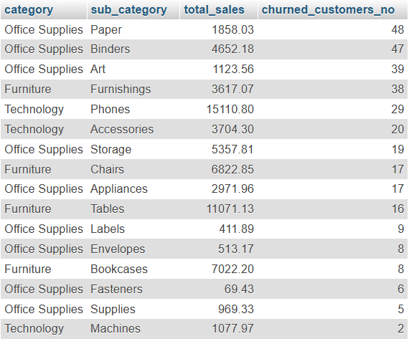
Figure 2 Churn Order Table
These are the last items (subcategory) that the churned customers bought before they leave.
*Can be investigated further about their quality and what caused the customers to churn.

Day 6 – Possible Churning Customers
According to analysis there are 4 customers that are about to churn. This is calculated using the average gap between each purchase of the customers, their last purchase date and the final business sales date. According to data, there are four customers who haven’t bought for a long time and are about to churn (exceed inactive time window 100).

Possible Retention Strategies Suggestions

Promotional Emails
This suggestion can be more effective with larger number of sample sets but in this case the company can carry out retention effort by sending promotional discount emails to the half of the sample dataset and setting other half as a foundation. For example, targeting four customers who are about to churn, we can send promotional emails such as “We miss you with 10% discount coupon” to 2 of the customers and leaving other 2 as baseline. This strategy carried out with larger sample set can help data science team find out if these promotional emails can bring back customers or not and what happens if we do nothing about the customers who are about to churn by analyzing another half.

Investigating Possible Causes for Churn Orders
According to findings in day 5, products such as papers, binders, and arts caused multiple churning rate among customers. This can be further investigated what is the main cause of these products causing the customers to churn. For example, is it the long delivery date of these products that makes customers leave or is it the quality of these products the customers are unsatisfied with. This analysis can help store improve in areas where the customers are unsatisfied.

